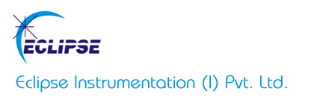

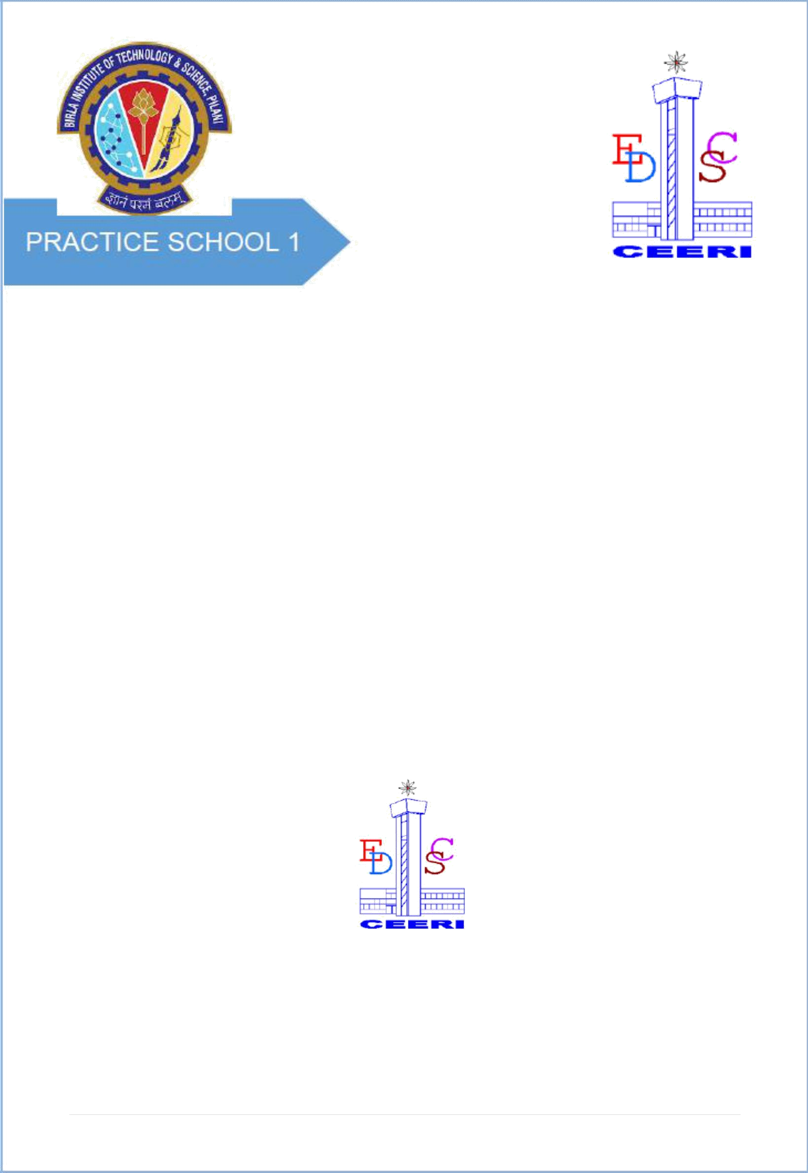

# PROJECT REPORT

**ON**

**WIRELESS VIDEO DATA TRANSMISSION**

**BY**

### PARTH AGGARWAL 2018A8PS0041G

**Prepared in partial fulfillment of the Practice School – I Course**

### at



**Eclipse Instrumentation Private Limited**

**A Practice School-I station of**

### BIRLA INSTITUTE OF TECHNOLOGY & SCIENCE, PILANI

**June, 2020**

**1 |** P a g e



**A REPORT ON**

**WIRELESS VIDEO DATA TRANSMISSION**

# BY

### Name of the ID.No. Discipline Student

**PARTH AGGARWAL 2018A8PS0041G Electronics & Instrumentation**

**Prepared in partial fulfillment of the Practice School-I Course**

**COURSE NO : BITS F221**

*AT*

### Eclipse Instrumentation Private Limited

A Practice School-I/II station of

### BIRLA INSTITUTE OF TECHNOLOGY & SCIENCE, PILANI

**June, 2020**

**ACKNOWLEDGEMENT**

I would like to thank everyone for providing me this opportunity, to learn and utilize my knowledge throughout the course of this project. I am extremely thankful to everyone for providing me their valuable insights, proper guidance and timely advice. I am sincerely grateful to them for helping me through any difficulties; I have been facing in this project.

I would also like to thank Priyal Nagare, Marketing Director of Eclipse Instrumentation Private Limited for motivating us and providing us this opportunity to work at this esteemed institute. I would also like to thank Dr.Noel Prashant Ratchagar, PS Coordinator and Pavan Kumar for their co-operation. I would also like to extend my heartfelt gratitude to Adityapratap Singh for providing me his valuable time and giving me this great opportunity of working under him on such an interesting topic.

I would especially like to thank Practice School Division for their constant support, maintaining discipline and helping us make the most of our time during PS-1.

### BIRLA INSTITUTE OF TECHNOLOGY AND SCIENCE PILANI (RAJASTHAN)

**Practice School Division**

**Station** ……… Eclipse Instrumentation Pvt. Ltd. ………. **Centre** ..................Thane… **Duration**....................20days………………… **Date of Start**.........May 18, 2020……

**Date of Submission** ..................…………June 6, 2020……………………………………

**Title of the Project**: WIRELESS VIDEO DATA TRANSMISSION

### Name(s) Discipline(s)/of the student(s) ID No.

PARTH AGGARWAL Electrical and Instrumentation 2018A8PS0041G

### Name(s) and designation(s) of the expert(s):

Adityapratap Singh,Product development Engineer, Eclipse Instrumentation Private

Ltd.

**Name(s) of the PS Faculty:** DR. NOEL PRASHANT RATCHAGAR

**Key Words:** WiFi networks, LAN, Backlight Propagation,OT Lights, Hardware Modifications

**Project Areas:** Surgical Lighting

**Abstract:** As the technology progresses, wired systems are being replaced by wireless solutions to make installation's easier and cost effective. This report deals with the Wireless Video Transmission, one of such technologies and finding out the correct system for the given specifications based on latency, range, cost, reliability, ease of use , etc and if required then modifying it to our needs. The technology should be compatible with the camera used in operation theatre lights.

Signature of Student Signature of PS Faculty

Date: Date:

|  |  |  |
| --- | --- | --- |
|  | **TABLE OF CONTENTS** |  |
| ***i.*** | ***Cover Page*** | ***i*** |
| ***ii.*** | ***Title Page*** | ***ii*** |
| ***iii.*** | ***Acknowledgements*** | ***iii*** |
| ***iv.*** | ***Abstract*** | ***iv*** |
| **1.** | **Introduction** | **1** |
| **2.** | **Terminologies** | **2** |
| **3.** | **Norms** | **4** |
| **4.** | **Wireless Broadcast Technologies** | **5** |
|  | **4.1. OFDM Technology**  **4.2. Video Links Over Cellular Networks**  **4.3. Video Links Over WiFi** |  |
| **5.** | **Lighting Methods Common to Operating Rooms** | **7** |
|  | **5.1. Overhead/Operating Lights**  **5.2. Headlamps/Illuminated Loupes**  **5.3. In Cavity Lighting** |  |
| **6.** | **Different Devices Available** | **9** |
|  | **6.1. Mars 400** |  |
|  | **6.2. Teradek Bolt 500 XT** |  |
|  | **6.3. Hollyland Mars 400S**  **6.4. Teradek Vidiu Go**  **6.5. Accsoon Cineeye Air** |  |
| 1. **Conclusion 11**    1. **Targets To Be Achieved** 2. **Appendices**      2. **Camera Support for Operation Theatre Videography 12**    3. **Video Transmission Over Wireless Networks Review And Recent Advances 14** 3. **References 16** 4. **Glossary 17** | | |

# INTRODUCTION

This report’s primary objective is to elaborate on our project – Wireless Video Data Transmission and identifying the correct technology used in camera of Operation theatre surgical lights (OTL).

Surgical lights provide the surgical team with bright, consistent lighting focused on the operation table during surgery. Surgical lights can be categorized based on the light type as either incandescent (conventional), LED lights and Halogen lights. There are many different types of lighting technologies to choose from. Knowing the difference between incandescent and LED and the difference between halogen and LED can help you make an educated decision on what’s best for your application and budget.

**INCANDESCENT**

Incandescent bulbs use—at most—10 percent of the energy they consume to make visible light; the other 90 percent is wasted heat. They produce infrared (IR) and ultraviolet (UV) radiation. They’re designed to last around 1,200 hours.

**HALOGEN**

They contain a tungsten filament, a small amount of halogen gas mixes with tungsten vapor and deposits it back onto the filament instead of on the inside of the bulb envelope. This process extends the bulb’s lifespan and allows it to work at a much higher temperature than incandescent bulbs, which increases light output.

**LED**

Light-emitting diode lights have been a revolutionary improvement in the field of surgical lighting, virtually eliminating the problem of infrared radiation caused by excessive heat. LEDs run much cooler. They can last up to 50,000 hours—42 times longer than incandescent bulbs and 13 times longer than halogen bulbs.

There are three leading wireless broadcast link technologies – each based on a different transmission method:1) OFDM / COFDM solutions 2)Cellular network solutions 3) Video over Wifi solutions.

In the next section these technologies are further explained in brief detail. The focus of project is more towards identifying the best suited technology for video data transmission used in camera of OT Lights. Some norms like Lux, Central illuminance, light field centre, depth of illumination, shadow dilution, light field diameter(D10 and D50) are also explained for reference.

# TERMINOLOGIES

[**Lux**](https://en.wikipedia.org/wiki/Lux):

Unit for the amount of visible light measured by a [luxmeter](https://en.wikipedia.org/wiki/Luxmeter) at a certain point.

**Central illuminance (Ec):**

[Illuminance](https://en.wikipedia.org/wiki/Illuminance) (measured in lux) at 1m distance from the light emitting surface in the

[light field](https://en.wikipedia.org/wiki/Light_field) centre.

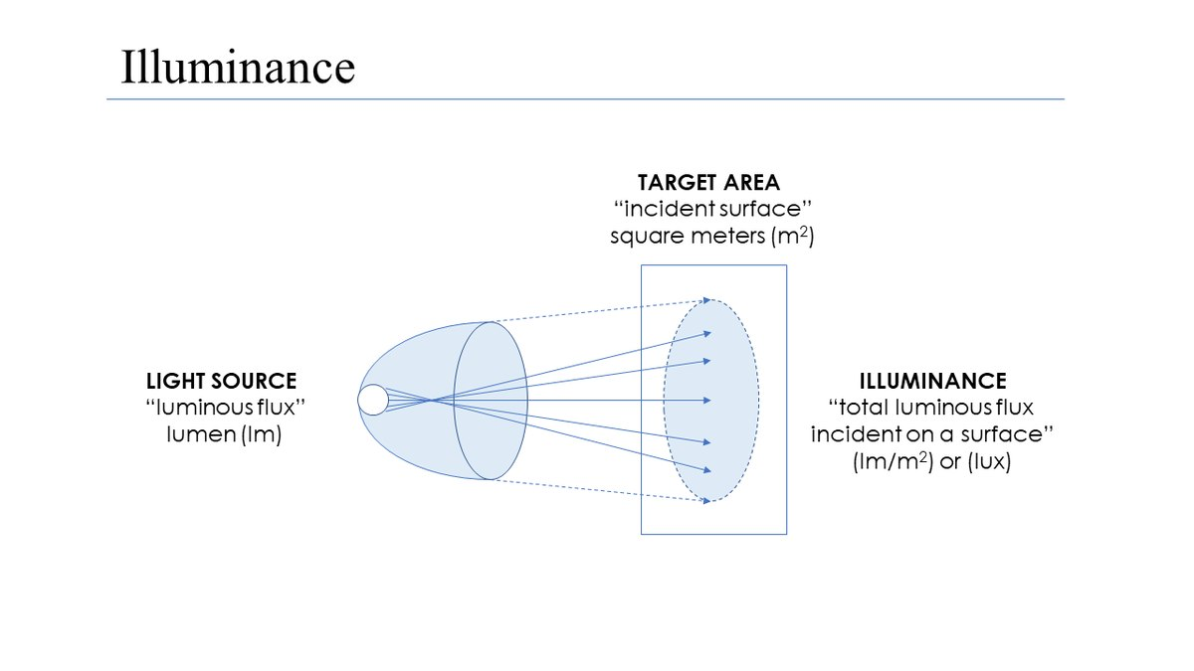

Figure 1: Illuminance Image Source:<https://en.wikipedia.org/wiki/Illuminance>

**Light field centre:**

Point in the light field (lighted area) where illuminance reaches maximum lux

intensity. It is the reference point for most measurements.

**Depth of illumination:**

The distance between the points of 60% illumination intensity above and below

the center point. From the point of maximum illumination, which is the center of

the light field 1 meter from the light-emitting surface, the photometer is moved

toward the light until the light intensity measured falls to 60% of the maximum

value. The distance between the center and this point is defined as L1. The

similarly measured distance in the direction away from the light is L2.

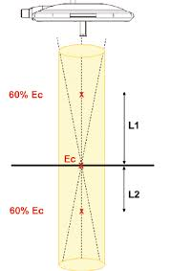Source:<https://www.surgiris.com/sites/surgiris/files/brochures/epure-plaquette-en_bd_1.pdf>

Figure 2 : Depth of Illumination=L1+L2

[**Shadow**](https://en.wikipedia.org/wiki/Shadow)**dilution:**

The light's ability to minimize the effect of obstructions.

**Light field diameter (D10):**

Diameter of light field around the light field centre, ending where the illuminance reaches 10% of Ec. The value reported is the average of four different cross sections through the light field centre.

**D50:**

Diameter of light field around the light field centre, ending where the illuminance reaches 50% of Ec. The value reported is the average of four different cross sections through the light field centre.

**Surgical Light Field Diameter:**

Surgical lighting should have the ability to adjust to a wide range of light fields. A light field diameter of D10 is the diameter of light field around the light center, where the illumination is 10 percent Ec. A light diameter of D50 should not exceed 50% of a

D10 diameter. The illustration below represents this functionality. The smaller

arrow is D50 while the larger arrow is D10. This simply means that 50 percent of the entire pie of light intensity should fall within 50 % of its total diameter.

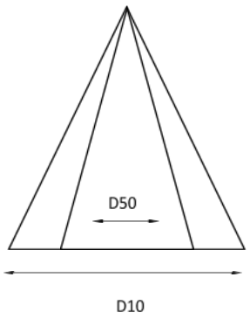   
Figure 3: It means that 50% of light intensity should fall within 50 % of its total diameter.

Source**:** [**https://www.usamedicalsurgical.com/blog/surgical-lights-buyers-guide/**](https://www.usamedicalsurgical.com/blog/surgical-lights-buyers-guide/)

**NORMS**

**Lux**:

The central illuminance should be between 160,000 and 40,000 [lux](https://en.wikipedia.org/wiki/Lux).

**Homogenous light**:

The light should offer good illumination on a flat, narrow or deep surface in a

cavity, despite obstacles such as surgeons' heads or hands.

**Colour rendition**:

For the purpose of distinguishing true tissue colour in a cavity, the colourrendering index (Ra) should be between 85 and 100.

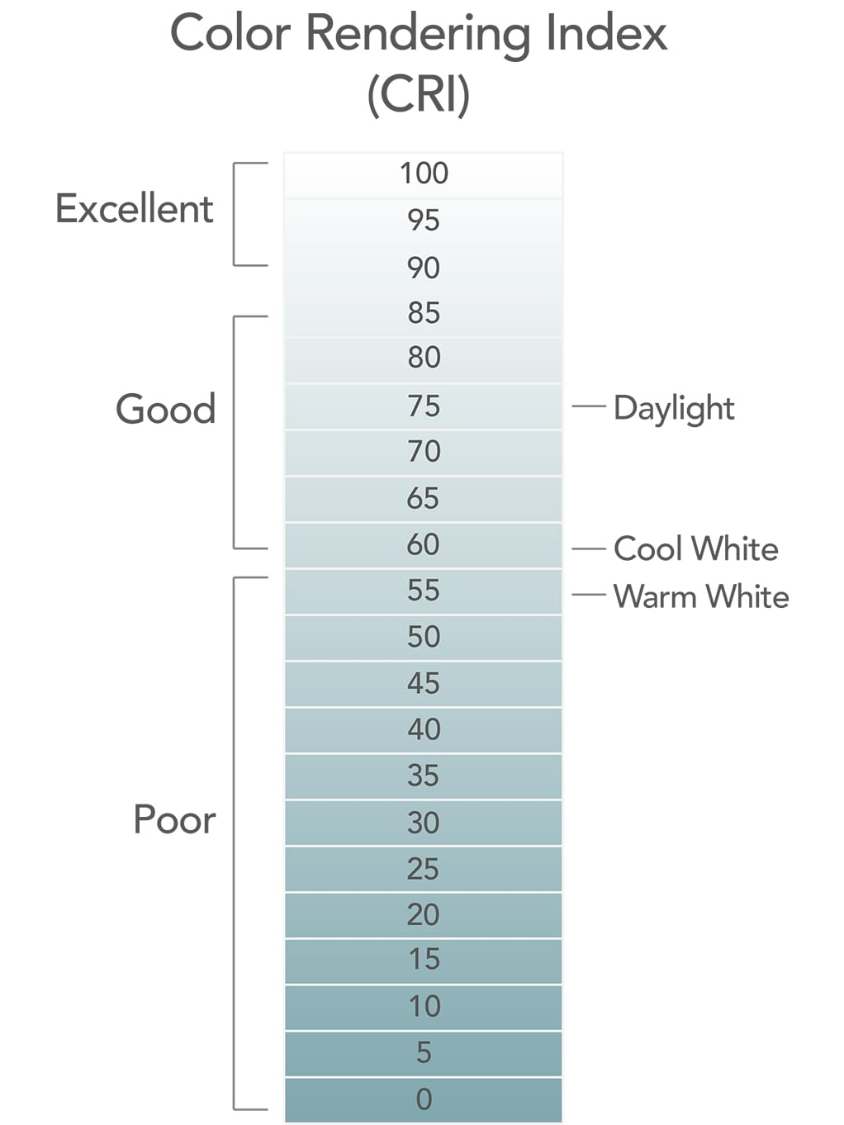

Source:<https://www.lumens.com/light-bulb-facts/color-rendering-index.html>

Figure 4: Greater than 70 is considered to be a good Ra.

[**Backup**](https://en.wikipedia.org/wiki/Backup_power)**possibility**:

In case of interruption of the power supply, the light should be restored within 5

seconds with at least 50% of the previous lux intensity, but not less than 40,000

lux. Within 40 seconds the light should be completely restored to original brightness.

# Light field diameter:

# The D50 diameter should be at least 50% of D10.

# WIRELESS BROADCAST TECHNOLOGIES

The three leading wireless broadcast link technologies are explained as follows:

1. **OFDM TECHNOLOGY**

OFDM is a method of encoding digital data on multiple carrier frequencies. OFDM /

COFDM based wireless video link systems consist of transmitters and receivers. The transmitter is positioned on camera; the receiver is located inside the OB-van or at

event’s media center where the content is gathered and transmitted forward.

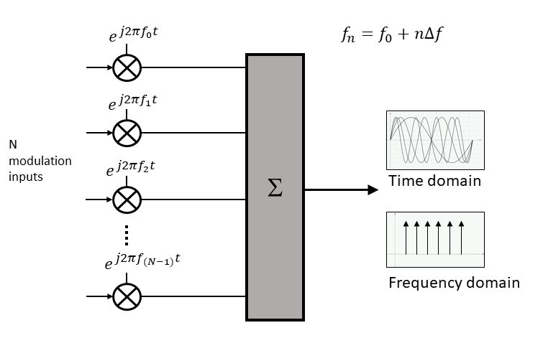

Figure 5: Encoding Digital Data on multiple carrier frequencies.

Source:<https://www.5gtechnologyworld.com/the-basics-of-5gs-modulation-ofdm/>

1. **VIDEO LINKS OVER CELLULAR NETWORKS:**

In wireless video links over cellular networks, the transmitter is positioned on the

camera or in a backpack carried by cameraman, transmitting the content over cellular network and from there to the broadcaster’s servers. The receiver is usually software

on the server. Cellular systems often encounter congestion.

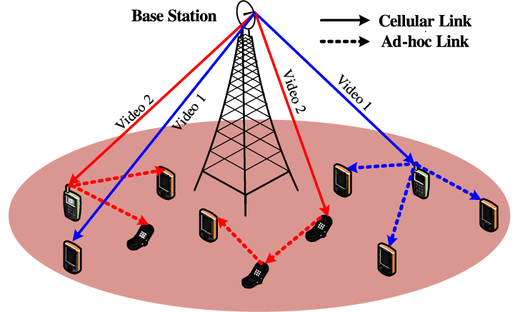

Figure 6: Video Dissemination over Hybrid Cellular and AdHoc Networks

Source:<https://www.computer.org/csdl/journal/tm/2014/02/ttm2014020274/13rRUEgs2tZ>

1. **VIDEO LINKS OVER WIFI**

In video over WiFi systems. The transmitter is located on camera and the receiver is

either near the WiFi access point in the same location or at the TV station beyond

internet cloud. The main advantage of WiFi video link solutions is their low cost,

making the a perfect choice for low-budget productions.

Combining two solutions can overcome some of these inherent technological limitations. For example when employing OFDM in a congested cellular environment OFDM link can be used to “jump” the first few hundred meters away from the cellular congestion. This solution enables the cellular transmitter to connect to clear cell,far away from the event, avoiding congestion ad transmitting the braodcast live with minimal delay.

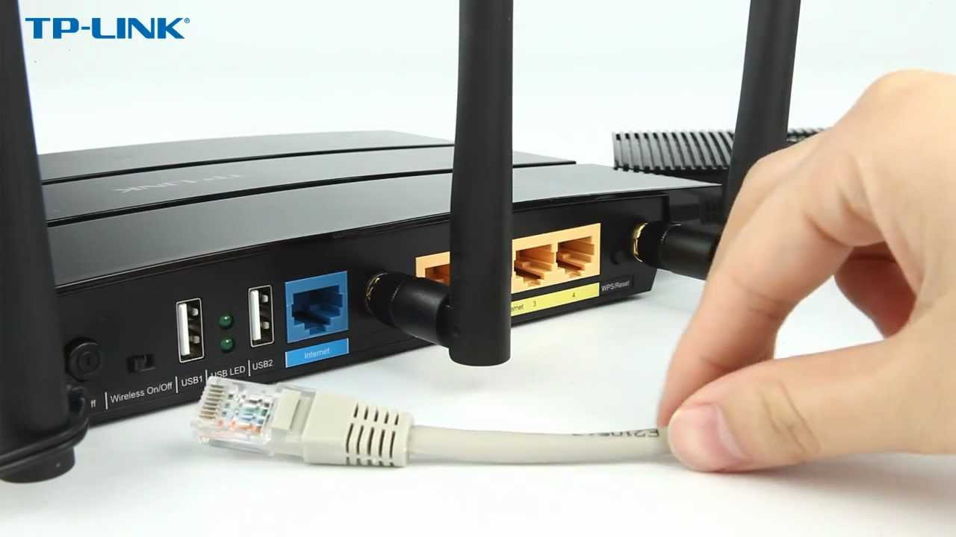

Figure 7: A TP-Link WiFi Router

Source: <https://www.youtube.com/watch?v=k9zyKOI-AGs>

### LIGHTING METHODS COMMON TO OPERATING ROOM

Quality lighting is critical for every operating room, and the method of light varies depending on staff needs. Three of the most prevalent methods are:

# OVERHEAD/OPERATING LIGHTS

Overhead lights are usually either LED or incandescent. The lighting fixture can be mounted on a ceiling or wall and have handles that allow the surgeon to adjust the lighting as they see fit. It is also adjustable to help prevent glare. One challenge with overhead lighting is the possibility of not *precisely* illuminating the operating room.  These types of light allow for something called the “brute force approach,” which floods operative site with large amounts of light. It can create a diffused light pattern with strategic lenses. For new OR lights, we need to assess factors such as shadow reduction and heat generation.

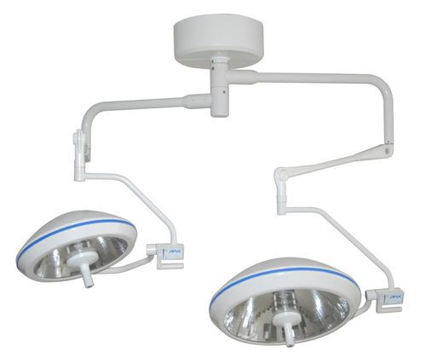

Figure 7: An Overhead Surgical Light

Source:<https://www.tradeindia.com/fp4040544/Overhead-Surgical-Lights.html>

# HEADLAMPS/ILLUMINATED LOUPES

Headlamps can offer brightness, dependability and comfort for surgeons. The lights are wearable and allow light to follow the attention of the surgeon. Headlamps help create mobility for the surgeon and shadow -free illumination.They can be battery-powered or connected to a standalone light source with a fiber optic cable. Often these surgical loupes feature a small lamp attached to the center of the frame to illuminate the operative site. Illuminated surgical loupes are critical in some cases because they enhance and magnify an area during surgeries requiring a high level of dexterity when working with small structures.

# Integra Lifesciences 90500 - McKesson Medical-Surgical

# Figure 8: A Surgical Headlamp

# Source: <http://www.telidis.gr/product/dlx-headlight/>

# 3.IN-CAVITY LIGHTING

In-cavity lighting allows for lighting deep inside surgical cavities. With this type of light, light source is typically outside of sterile field, meaning it can be fixed light on its own or connected to a surgicalretractor or instrument.In-cavity lighting can be customized to specific needs and levels of illumination within surgical corridor.If surgery is taking place within deep, minimally invasive corridor,**in-cavity lighting can be used with fiber optics** to eliminate factors such as added heat.

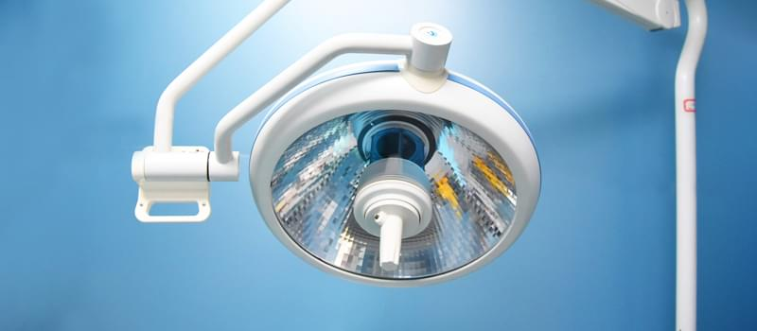

Figure 9:In cavity lighting produces Minimum Heat

Source:<https://www.amismedical.com/why-led-surgical-light-is-critical-to-ors/>

# DIFFERENT DEVICES AVAILABLE

Monitoring your video production is always a challenge when you need multiple eyes on the shot to get it right, and there are a lot of eyes. However, with a wireless video transmission revolution fully underway, it can be difficult to wade through all the options for what you need especially regarding price.

* **MARS 400**

Most wireless transmission systems on the market right now support up to 1080p60 input and transmission, and many support HDR workflows, which will suit visual needs and requirements of most portable monitors. The Mars 400 transmitter features HDMI input up to 1080p60, and receiver has two HDMI outputs for monitors, computer or switches.

* **TERADEK BOLT 500 XT**

The Teradek Bolt 500 XT 3G-SDI/HDMI Wireless Transmitter and Receiver Set include one transmitter and one receiver. This enables you to immediately start transmitting up to 1080p60 video from SDIor HDMI source. The zero-latency transmitter/receiver pair features a 500' line-of-site transmission distance. It is Backward Compatible with Select Systems. It has cross conversion.

* **HOLLYLAND MARS 400S**

The Mars 400S from Hollyland is an entry-level 1080p60 transmitter/receiver system featuring a 400' line-of-sight transmission range. In a compact design, transmitter and receiver each have an SDI and HDMI connection. It has Wi-Fi Transmission to 4 Mobile Devices. It has L-Series Battery Plates. It supports up to 1080p24.

Figure 10:

Source:<https://www.bhphotovideo.com/c/product/1519703-REG/hollyland_hl_mars_400_mars_400_dual_hdmi.html>

* **TERADEK VIDIU GO**

The Teradek VidiU Go is a live video transmission system that supports both HDMI and 3G-SDI signals up to 1080p60. It features two USB 2.0 ports for streaming using USB modems, and you can also use the Ethernet and Wi-Fi ports to stream. The VidiU Go is a bonded device and uses Teradek Core technology, which allows you to distribute the bandwidth of your streaming signal between attached modems decreasing the chance of dropping frames and increasing the quality of your stream.

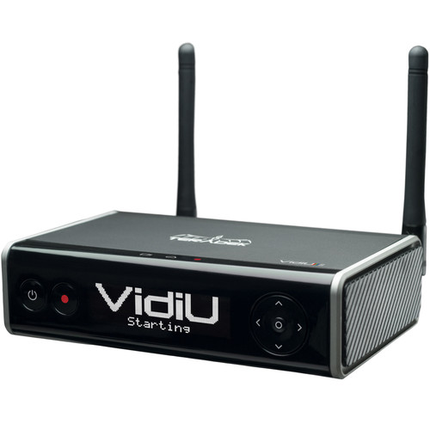

Figure 11: Teradek Vidiu Router

Source:<https://www.bhphotovideo.com/c/product/1401708-REG/teradek_10_0229_vidiu_go.html>

* **ACCSOON CINEEYE AIR**

The Accsoon CineEye Air simultaneously transmits up to a 1080p video signal from an HDMI source to two iOS/Android mobile devices such as smartphones and tablets, treating them as video receivers and allowing you to use them as real-time video monitors.It sends to up to 2 devices simultaneously.

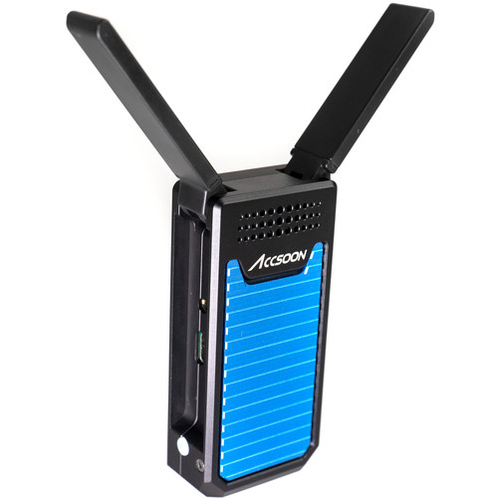

Figure 12:Accsoon Cineeye Air 5 GHz Transmitter

Source:<https://www.bhphotovideo.com/c/product/1538166-REG/accsoon_wit01_m_5g_wi_fi_video_transmitter.html>

# 7.Conclusions

A semiconductor rich in electrons and a semiconductor rich in holes are used to create an LED. Passing a current through the junction of these two materials combines the electrons with the holes and produces photons, which is the light that you see. LEDs have endless application possibilities, such as [undercabinet](https://www.superbrightleds.com/cat/led-strips-and-bars/), landscape, vehicle,home, industrial,and commercial lighting.

**BENEFITS OF LED SURGICAL LIGHTS**

* Brighter white colors
* More accurate colors
* Significantly more energy efficient
* Last much longer (20x-30x longer)
* Emit virtually no heat

# Some of the technologies used in video data transmission are-

* **MARS 400**
* **TERADEK BOLT 500 XT**
* **HOLLYLAND MARS 400S**
* **TERADEK VIDIU GO**
* **ACCSOON CINEEYE AIR**

**TARGETS TO BE ACHIEVED**

* Finding the technology most suitable for use, with the given set of requirements and then applying modifications to the system as per requirement.
* Finding the compatibility of the technology for the upcoming future needs is also one of the tasks to be done.
* Finding different ways to increase the efficiency for OTL camera system.

# APPENDIX A: CAMERA SUPPORT FOR OPERATION THEATRE

# VIDEOGRAPHY

Various methods of digital video recording in the operating theatre include e**ndoscopic cameras** , **head-mounted cameras** , cameras mounted on the surgical light , miniature cameras placed directly in the operative field and specially constructed arms .

# The main elements restricting camera placement in the operating theatre are:

# 1. The surgical team : Surgeons and sterile nurses work close to the operative field, blocking the view from most angles.

# 2. The operating theatre equipment : Both fixed (lamps, ceiling-mounted racks etc.) and mobile equipment in the operating theatre restrict the placement of the camera.

# 3. Anatomical orientation:For viewer, the video image ina surgical video needs to be orientated according to the anatomy. This mean that the cranial direction is screen up and the caudal direction screen down. When deviating from this (e.g. operations in the pelvis) it is preferable to choose surgeon’s viewpoint.

# In order to put the camera up and above the operative field, the support is designed like gallows ’ , with the camera mounted on the distal end of a horizontal boom that extends laterally from the top of a vertical support column ( Figure 13).

# https://www.researchgate.net/profile/Havard_Danielsen/publication/221684153/figure/fig1/AS:552629584568320@1508768568406/3D-model-of-the-camera-support-J-Vis-Commun-Med-Downloaded-from-informahealthcarecom-by_W640.jpg

# Figure 13: 3D model of the camera support

# Source:<https://www.researchgate.net/publication/221684153_A_camera_support_for_operating_theatre_videography>

# The column rests on an electric lifting column, which provides both a low centre of gravity and a motorized height-adjustment of 40 cm. The lifting column rests on a ‘ U ’-shaped base fitted with four anti-static wheels on castors that rotate 360 ° . This makes it easy to move support using four handles placed on the sides of the column and boom. A padded ring is placed around the camera, to protect it from damage and make it easier to place a sterile drape around it when that is required.

# All the electrical wiring is placed inside the support: video and remote cables from the camera and power to the camera and lifting column. The power is turned on/off with a switch on a junction box at the bottom back of support. The lifting column is operated with a foot switch placed on the bottom of the same box.

# All camera parameters (white balance, focus, aperture, pan, and zoom) are controlled between camera and recording unit achieved by placing the remote unit, HDD recorder and 8-inchliquid crystal display (LCD) monitor in portable plastic hard case (Figure 14).

# 

# Figure 14: Video still showing close-up of the operative field.

# Source: <https://www.researchgate.net/publication/221684153_A_camera_support_for_operating_theatre_videography>

# Before making a video recording the hard case unit is connected to the camera support with video and remote cables. The hard case can be set up on a small table in any available space in the operating theatre, out of the way of the surgical team. After use the support can be stored in the surgery ward, while the hard case is brought to the editing suite for transfer of the video material.

# APPENDIX B: VIDEO TRANSMISSION OVER WIRELESS NETWORKS REVIEW AND RECENT ADVANCES

**VIDEO STREAMING:**

Video streaming over computer networks is considered to become the most interesting application in the near future. There are three types of delivery methods of streaming media;Streaming Stored Audio- Video Streaming Live Audio and Video and Real-Time Interactive Audio and Video. Figure 15 show overall Architecture for Video Streaming. This kind of application needs large bandwidth, efficient routing protocols, and content delivery methods to provide smooth video playback to the receivers.

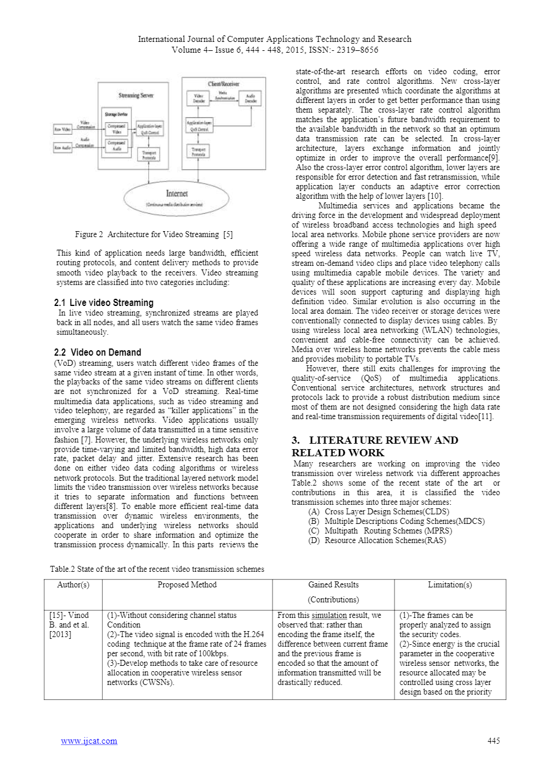

Figure 15 : Architecture For Video Streaming

Source: <https://www.researchgate.net/publication/279220589_VIDEO_TRANSMISSION_OVER_WIRELESS_NETWORKS_REVIEW_AND_RECENT_ADVANCES>

Video streaming systems are classified into two categories including:

2.1 Live video Streaming In live video streaming, synchronized streams are played back in all nodes, and all users watch the same video frames simultaneously.

2.2 Video on Demand (VoD) streaming, users watch different video frames of same video stream at a given instant of time. In other words, the playbacks of the same video streams on different clients are not synchronized for a VoD streaming. Real-time multimedia data applications, such as video streaming and video telephony, are regarded as “killer applications” in the emerging wireless networks. Video applications usually involve a large volume of data transmitted in a time sensitive fashion.

However, the underlying wireless networks only provide time-varying and limited bandwidth, high data error rate, packet delay and jitter. Extensive research has been done on either video data coding algorithms or wireless network protocols. But traditional layered network model limits the video transmission over wireless networks because it tries to separate information and functions between different layer.

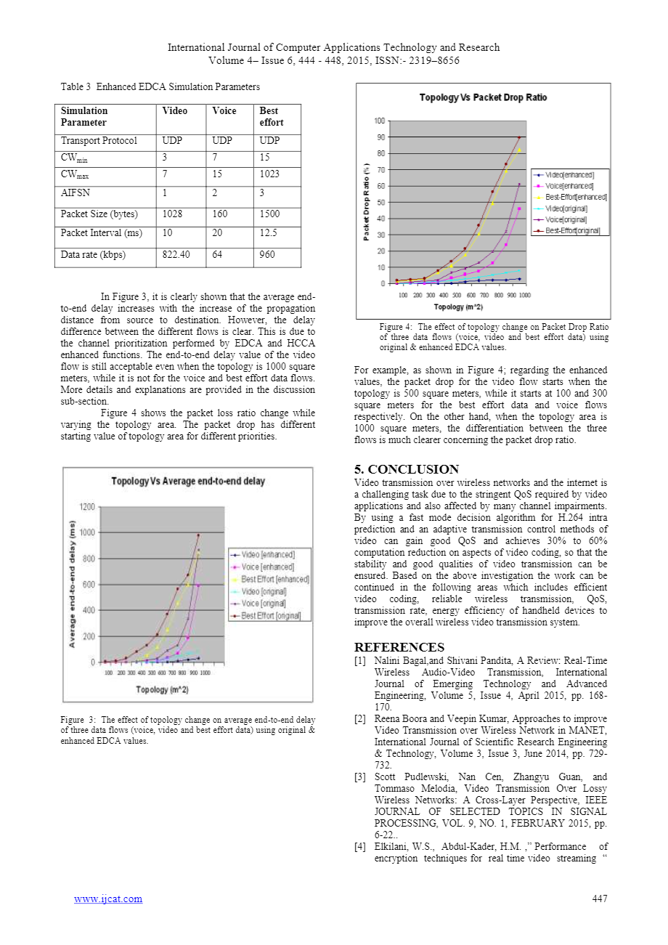

Figure 16 : Effect of Topology on average end to end delay

Source:<https://www.researchgate.net/publication/279220589_VIDEO_TRANSMISSION_OVER_WIRELESS_NETWORKS_REVIEW_AND_RECENT_ADVANCES>

In Figure 16, it is clearly shown that the average end-to-end delay increases with the increase of the propagation distance from source to destination. However, the delay difference between the different flows is clear. This is due to the channel prioritization performed by EDCA and HCCA enhanced functions. The end-to-end delay value of the video flow is still acceptable even when the topology is 1000 square meters, while it is not for the voice and best effort data flows.

Figure 17 shows the packet loss ratio change while varying the topology area. The packet drop has different starting value of topology area for different priorities.



Figure 17 : Effect of Topology change on Packet Drop Ratio

Source: <https://www.researchgate.net/publication/279220589_VIDEO_TRANSMISSION_OVER_WIRELESS_NETWORKS_REVIEW_AND_RECENT_ADVANCES>  
For example, as shown in Figure 17; regarding the enhanced values, packet drop for the video flow starts when topology is 500 square meters, while it starts at 100 and 300 square meters for the best effort data and voice flows respectively. On the other hand, when the topology area is 1000 square meters, differentiation between the three flows is much clearer concerning the packet drop ratio.

# References

* 1. <https://insights.regencylighting.com/what-is-correlated-color-temperature-cct-and-how-do-you-choose-it-for-your-lighting>
  2. <https://en.wikipedia.org/wiki/Color_rendering_index>
  3. D.E. Ahmed,O.Khalifa and Abdirisaq M.Jama,” *VIDEO TRANSMISSION OVER WIRELESS NETWORKS REVIEW AND RECENT ADVANCES”*, International Journal of Computer Applications Technology and Research, Volume 4– Issue 6, 444 - 448, 2015

Available from: <https://www.researchgate.net/publication/279220589_VIDEO_TRANSMISSION_OVER_WIRELESS_NETWORKS_REVIEW_AND_RECENT_ADVANCES>

* 1. <https://www.superbrightleds.com/blog/led-vs-incandescent-vs-halogen/707/>
  2. <https://www.usamedicalsurgical.com/blog/surgical-lights-buyers-guide/>
  3. <https://www.abonair.com/blog/2019/02/10/wireless-broadcast-transmission-overview-2/>
  4. <https://en.wikipedia.org/wiki/Surgical_lighting>
  5. Ø Ystein H. Horgmo And H Å Vard E. Danielsen “*A Camera Support For Operating Theatre Videography”*, Institute for Medical Informatics, Oslo University Hospital, Norway ,2012,p20-24  
      Available from: <https://www.researchgate.net/publication/221684153_A_camera_support_for_operating_theatre_videography>
  6. <https://www.lumitex.com/blog/surgical-lighting>
  7. <https://www.bhphotovideo.com/>

**GLOSSARY**

* **Ad-Hoc Network:**  It is a decentralized type of wireless network which does not rely on pre-existing infrastructure, such as routers in wired networks or access points in managed (infrastructure) wireless networks.
* **Colour Rendering Index:** It is a measure of a light source's ability to show object colours realistically or naturally. In other words, to accurately render all frequencies of its colour spectrum when compared to a perfect reference light of a similar type.
* **Endoscopic Camera:**  An endoscopiccamera is basically little camera along with a long cable which can be used to view tiny areas on a big screen.
* **HDMI:** High**-**DefinitionMultimediaInterface is proprietary audio/video interface  for transmitting uncompressed video data and compressed or uncompressed  digital audio data from an HDMI-compliant source device.
* **HDR:** Highdynamicrangeis a dynamic range higher than what is considered to be standard dynamic range. The term is often used in discussing display devices, photography, 3D rendering, and sound recording including digital imaging and digital audio production.
* **Head-Mounted Cameras:**  It is an action camera, usually a closed circuit television camera, attached to a helmet allowing someone to make a visual record from their point of view (POV), while keeping their hands and vision free.
* **Ob-Van:** Outside broadcasting is the electronic field production of television or radio programmes from a mobile remote broadcast television studio.
* **SDI:** Serial Digital Interface (**SDI**) is a standard for digital video transmission over coaxial cable.
* **Surgical Retractor:** It help **surgeons** and operating room professionals hold an incision or wound open during **surgical** procedures. They aid in holding back underlying organs or tissues, allowing doctors/nurses better visibility and access to the exposed area.
* **White Balance:** White balance (WB) is the process of removing unrealistic color casts, so that objects which appear white in person are rendered white in your photo. Proper camera white balance has to take into account "color temperature" of a light source.